PRESS RELEASE
COMMUNICATIONS AND MEDIA TEAM OF THE 43RD ASEAN SUMMIT 2023
No.111/SP/TKM-ASEAN2023/ENG/9/2023

UN Secretary-General: “Bhineka Tunggal Ika” is Not Only for Indonesia but also the World
Jakarta, 7 September 2023 – The United Nations (UN) Secretary-General Antonio Guterres praised the motto "Bhineka Tunggal Ika”, recognizing that it has the potential to unite and preserve diversity not only in Southeast Asia but also globally.
"Bhinneka Tunggal Ika signifies unity in diversity. It is not only the national motto of Indonesia. It is the key to building a better future for all of us," said Guterres during a statement to foreign and national media journalists at the Media Center of the 43rd ASEAN Summit in Jakarta on Thursday, 7 September 2023.
Guterres also acknowledged the constructive role of ASEAN under Indonesia's leadership in 2023 in promoting peace, especially in efforts to reduce tensions in the South China Sea and the Korean Peninsula by emphasizing dialogue and respect for international law.
During this occasion, the UN Secretary-General highlighted concerns about the conflict in Myanmar and expressed his deep concern.
He also appreciated and supported Indonesia's efforts to resolve the Myanmar conflict by bringing together all parties involved.
Guterres emphasized the importance of humanitarian values as he urged all nations to seek an integrated approach to the Myanmar situation
"We support ASEAN's efforts in finding a solution to the political situation in Myanmar. It's time for the international community to provide assistance to Rohingya refugees in Bangladesh," said Guterres.
Previously, Indonesia's Minister of Foreign Affairs Retno Marsudi stated that Indonesia continues to push for efforts to address the Myanmar crisis, particularly in implementing the Five-Point Consensus (5PC) approach. In practice, this approach requires engagement from all ASEAN Foreign Ministers.
The Five-Point Consensus calls for an immediate cessation of violence, dialogue among relevant parties, mediation by ASEAN special envoys, the provision of humanitarian assistance, and visits to Myanmar by special envoys to meet with all relevant parties.
During the retreat session of the 43rd ASEAN Summit at the Jakarta Convention Center on Tuesday, 5 September 2023, all ASEAN leaders appreciated Indonesia's efforts. Over the last nine months, Indonesia has made 145 approaches.
ASEAN's commitment to continuing to assist the people of Myanmar was reaffirmed through the establishment of a troika consisting of the current Chair, previous Chair, and next Chair. Non-political representation from Myanmar was maintained.
Guterres also emphasized the significance of ASEAN’s role as a multilateral institution capable of bridging gaps and fostering mutual understanding.
"We need this more than ever in a world that is increasingly divided and requires a strong multilateral institution to follow through, based on equality, solidarity, and universality," said Guterres.
***
For further information, please contact:
Director General of Public Information and Communications of the Ministry of Communications and Informatics – Usman Kansong (0816785320).
Get more information at http://asean2023.id, https://infopublik.id/kategori/asean-2023, and https://indonesia.go.id/kategori/ragam-asean-2023

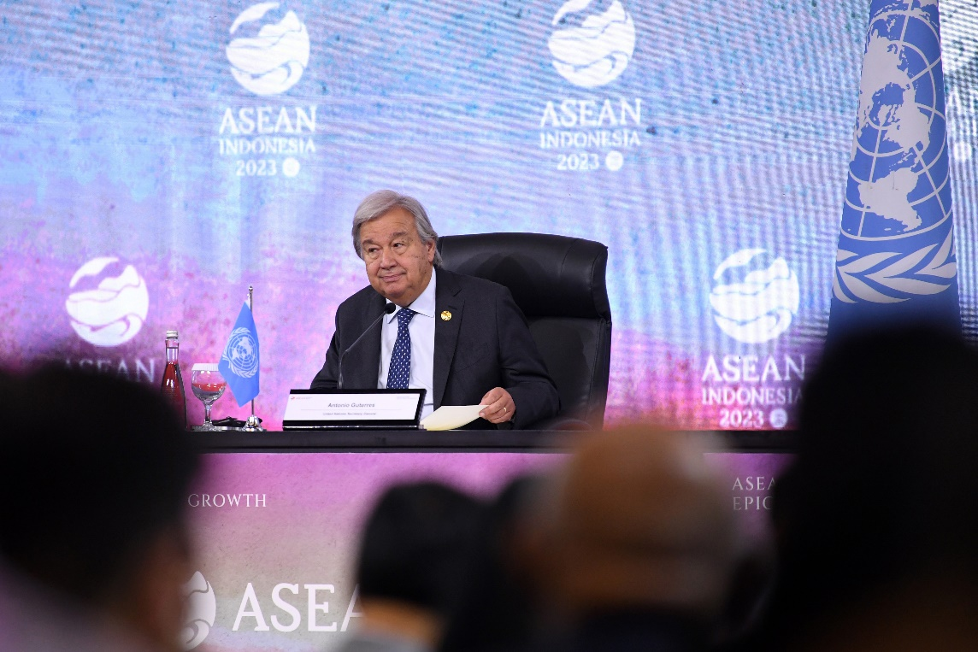

Secretary General of the United Nations (UN) Antonio Guterres (right) answers journalists' questions during a press conference at the 43rd ASEAN Summit at the Jakarta Convention Center, Jakarta, Thursday (7 September 2023). ASEAN Summit Media Center 2023/Harviyan Perdana Putra/foc.

